**Consistent Hashing**

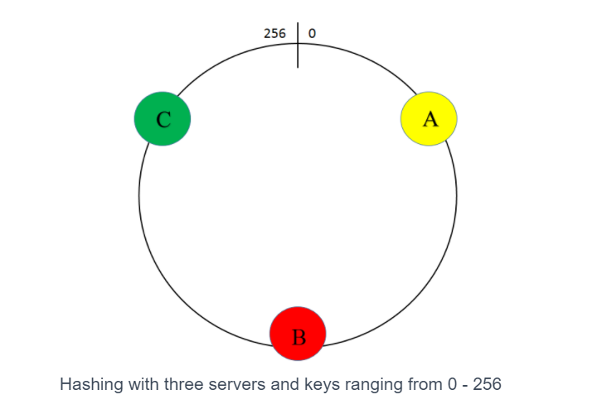

Here all the keys between A and B will be mapped to B, from B to C will be mapped to C and all the keys from C to A will be mapped to A.

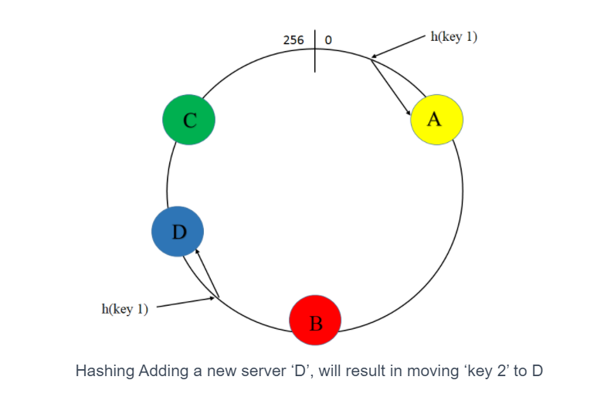

If we add a new server, then server A and B will be getting more keys as compared to C and D. If server A goes down then all the requests will move to Server B and it will create a bottleneck for server B.

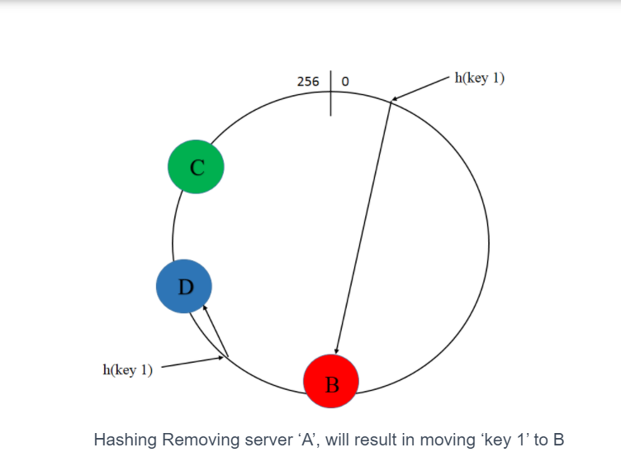

To overcome this, we will use consistent hasing. In consistent hasing, we will have virtual replica of each server A,B and C.

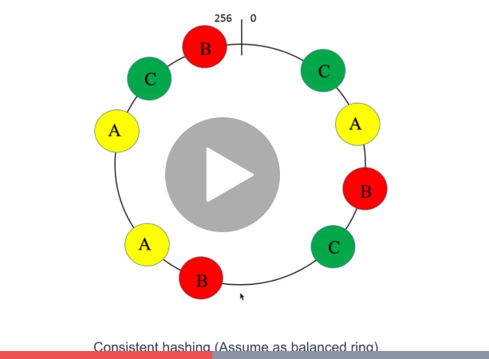

Here each server has two virtual replicas.

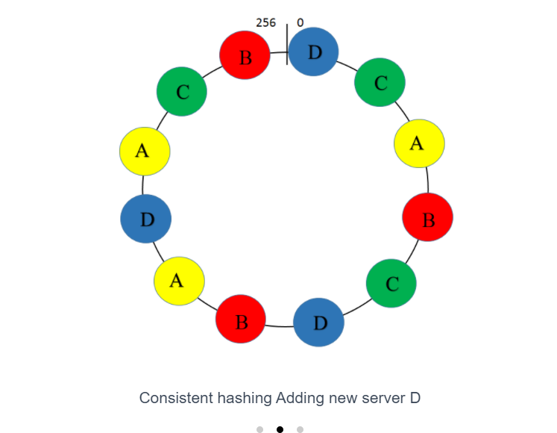

Here we have added a new server D. So here some keys from C,A and B will be given to D.

Here all the severs are given same amount of keys.

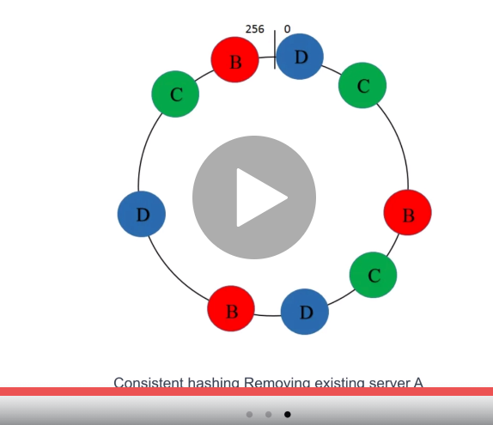

If server A goes down, it will distribute all its keys equally to B,C and D.

Cosistent hasing always distribute the data equally. It is heavily used in load balancers and database.

**Storage:-**

**Object store:-**

Object store is used to store unstruncted data,.Facebook uses it to store photos.

Youtube uses to store vidoes. All the objects have metadata associated with it.

Ex:- Amazon S3, Azure blob storage,

**RAID:-**

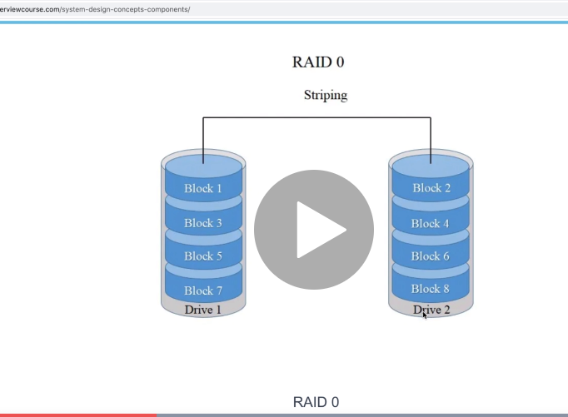

RAID 0 will store all the even disk into one drive and all the odd disks into another drive. There is no redundancy. So if any disk fails, there will be data loss,

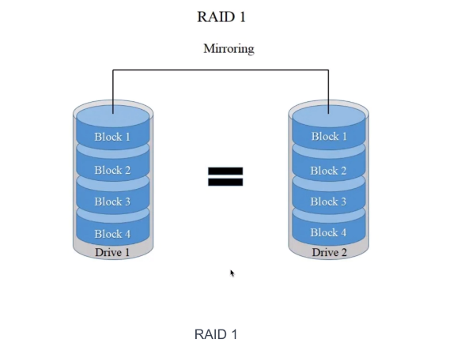

Here both the driver will contain same data, Read perfomace will improve as we can read from either of the disk but write performance will slow down,

It can save the data incase of failure.

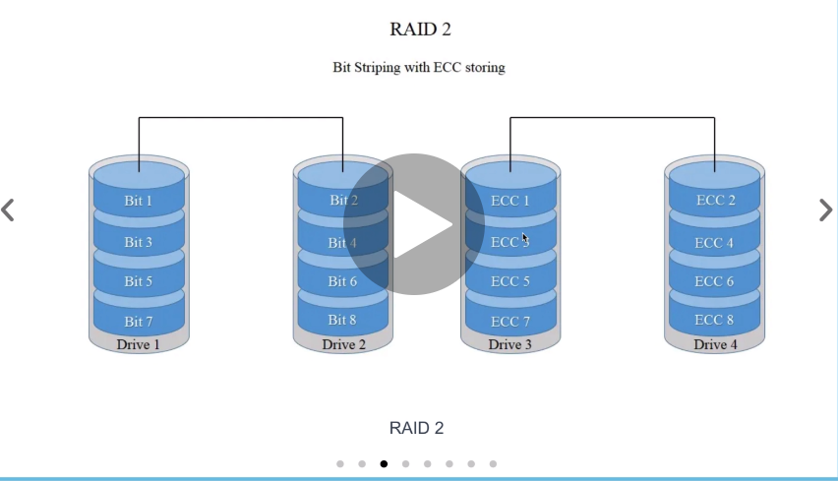

Here we will have a error correction disk, where if data fails the we can recreate the data using ECC.

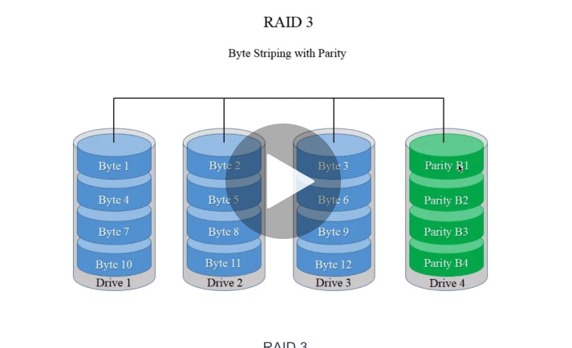

Here if any disk fails, the using the parity disk and the remaining disk, we can recover the failed disk.

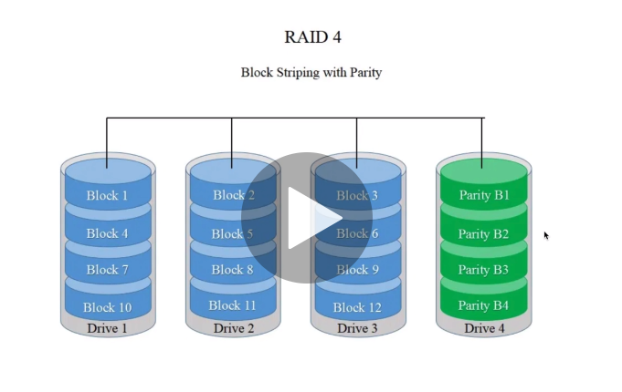

Here if Parity disk fails we can create the data from existing data we have. There is drawback is that if any of the disk changes, then we need to update the parity disk and there will be lot of wear and tear.

So to over come this we will use RAID 5.

Here parity is distributed across different drives.

# **CAP theorem**

From Wikipedia, the free encyclopedia

[Jump to navigation](https://en.wikipedia.org/wiki/CAP_theorem#mw-head)[Jump to search](https://en.wikipedia.org/wiki/CAP_theorem#searchInput)

In [theoretical computer science](https://en.wikipedia.org/wiki/Theoretical_computer_science), the **CAP theorem**, also named **Brewer's theorem** after computer scientist [Eric Brewer](https://en.wikipedia.org/wiki/Eric_Brewer_(scientist)), states that it is impossible for a [distributed data store](https://en.wikipedia.org/wiki/Distributed_data_store) to simultaneously provide [more than two out of the following three](https://en.wikipedia.org/wiki/Trilemma) guarantees:[[1]](https://en.wikipedia.org/wiki/CAP_theorem#cite_note-Gilbert_Lynch-1)[[2]](https://en.wikipedia.org/wiki/CAP_theorem#cite_note-2)[[3]](https://en.wikipedia.org/wiki/CAP_theorem#cite_note-3)

* [*Consistency*](https://en.wikipedia.org/wiki/Consistency_model): Every read receives the most recent write or an error
* [*Availability*](https://en.wikipedia.org/wiki/Availability): Every request receives a (non-error) response, without the guarantee that it contains the most recent write
* [*Partition tolerance*](https://en.wikipedia.org/wiki/Network_partitioning): The system continues to operate despite an arbitrary number of messages being dropped (or delayed) by the network between nodes

When a network partition failure happens should we decide to

* Cancel the operation and thus decrease the availability but ensure consistency
* Proceed with the operation and thus provide availability but risk inconsistency

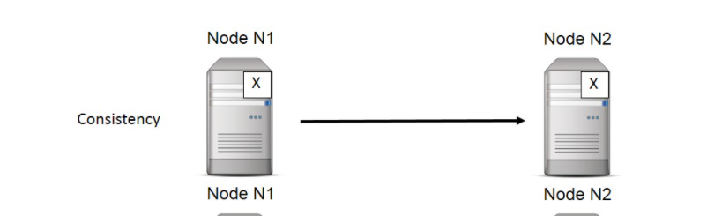

In consistency, it gurantees that the same value will be updated to both the nodes. Here in the above diagram, the value x is updated in both the nodes.

**Consistency Patterns**

Distributed databases that rely on replication for high availability, low latency or both, we need to make a trade-off between the read consistency vs throughput. There are 2 general consistency levels supported by most distributed databases.

1. Strong consistency
2. Eventual consistency

Strong Consitency:- if there is any write request and there are two databases B1 and B2, then data will be updated in both the servers then only the write will succeed.

Eventual Consistency:- if there is write request in B1, then it will be updated in B1. So if there is a read request in B1, then there will be stale data for some time.

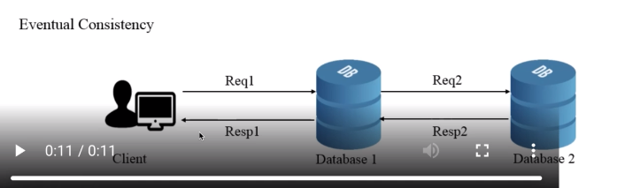

**Replication architectures**

1. Single-leader architecture
2. Multi-leader architecture
3. No-leader architecture

Single-leader Architecture:- Here we will have only leader database that draws write request from the client and multiple replicas can get the updated data from this single leader database.

Multi-leader Architecture:- Here we will have multiple leader that serves write request and replicas gets the data from these multiple leaders. Here there will be low latency since replicas can draw the data from the nearest leader ,so there will be low latency.

No Leader Architeture:- Here every database can serve writes and every data can serve can replicas. Here the challenge is to keep every database synchronised. Dynamo DB is an example.

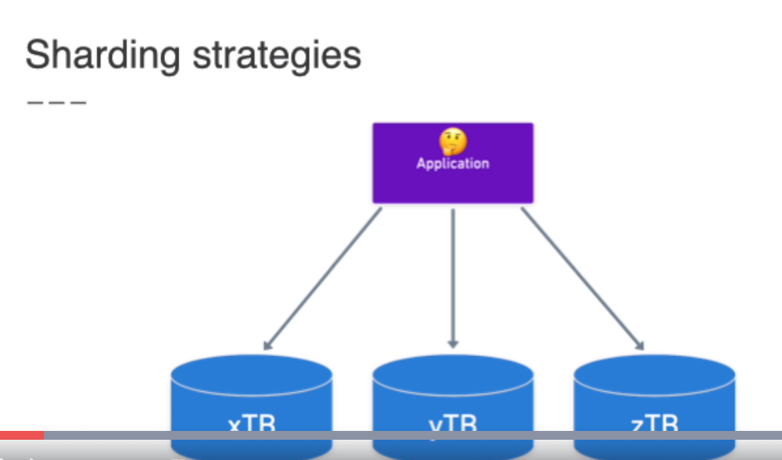

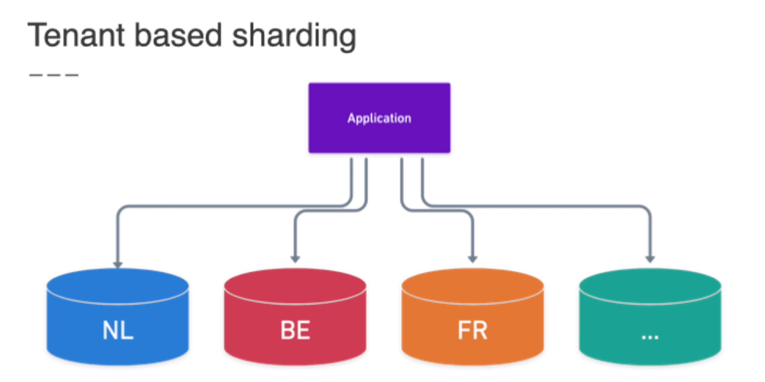

Geo sharding means based on location between locatons.

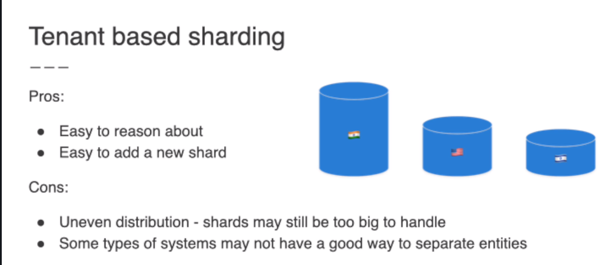

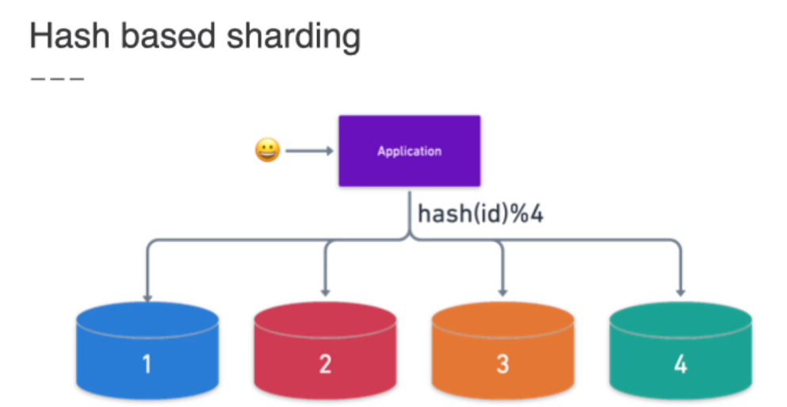

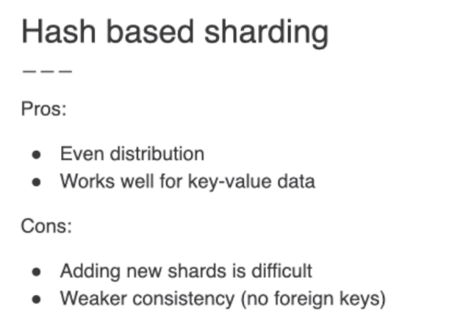

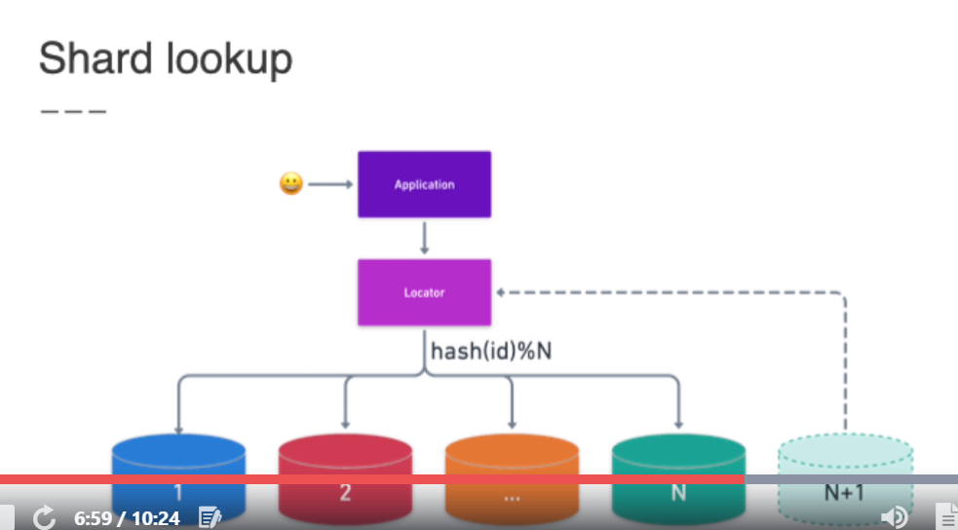

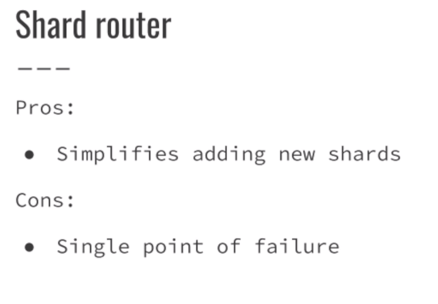

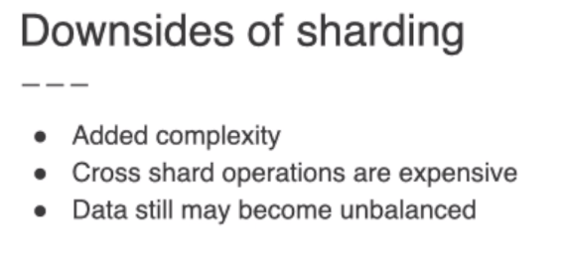

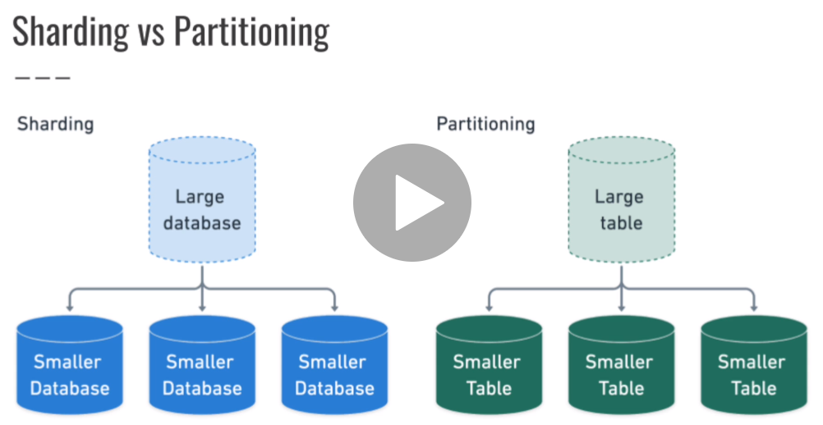

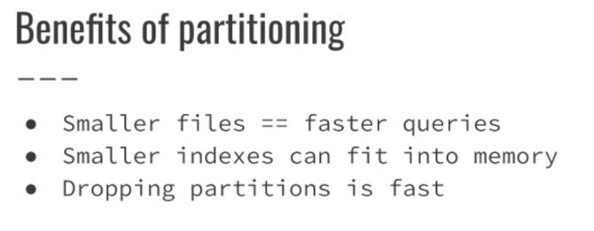

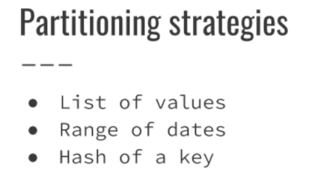

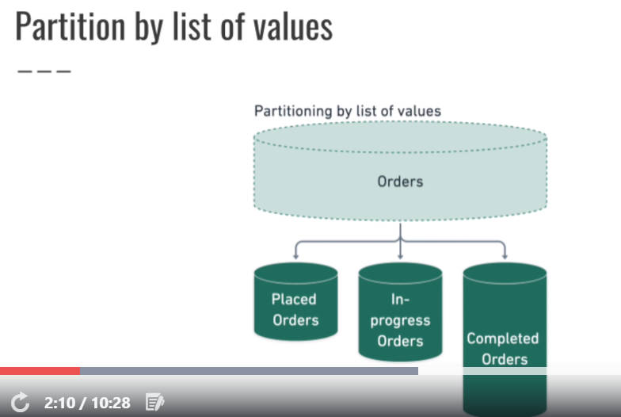

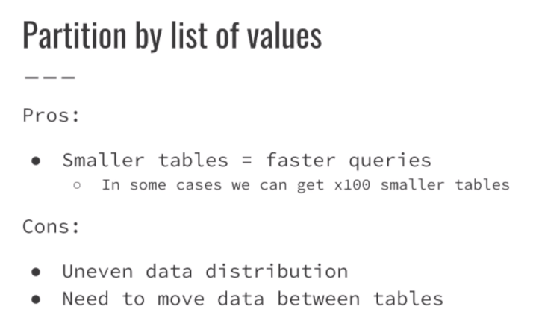

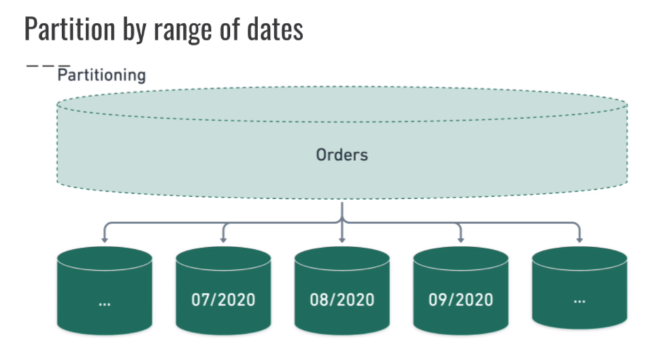

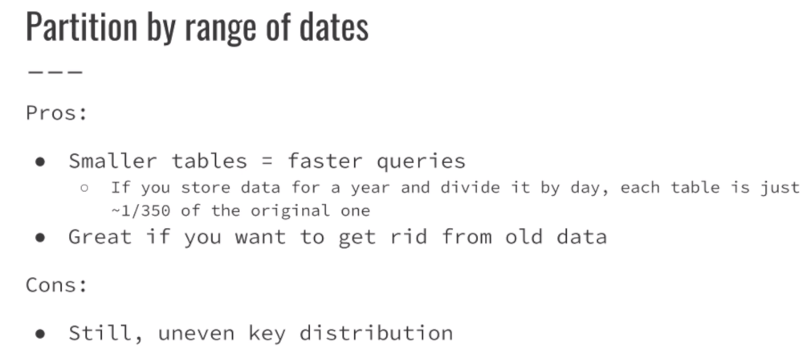

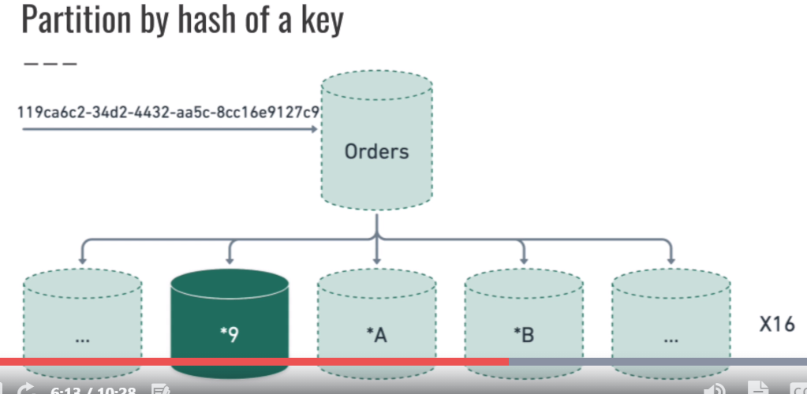

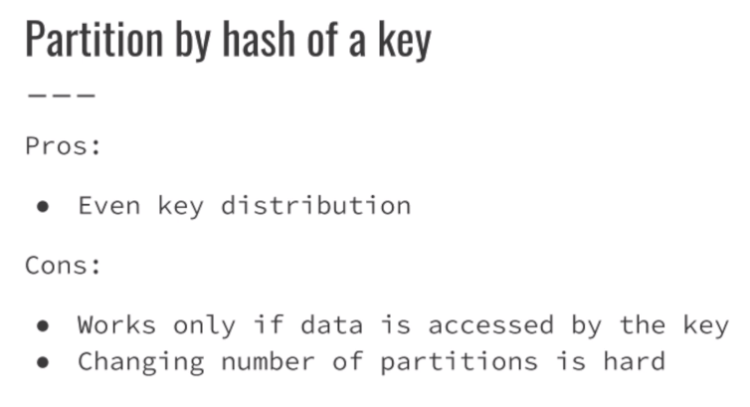

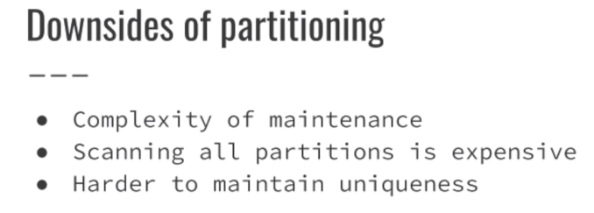



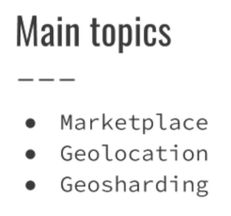

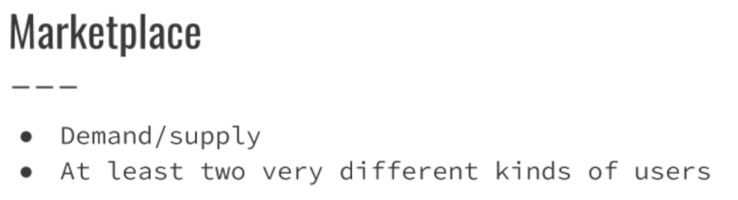

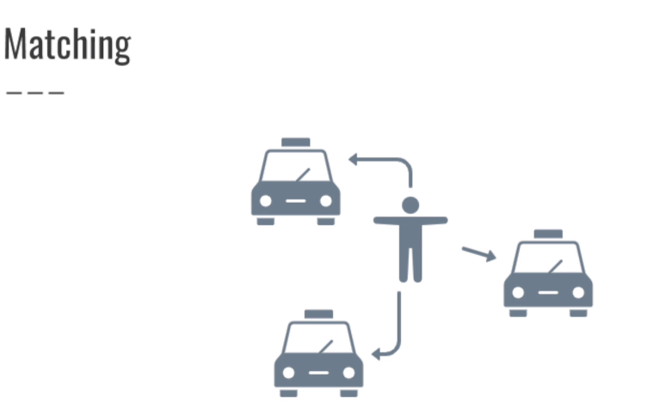

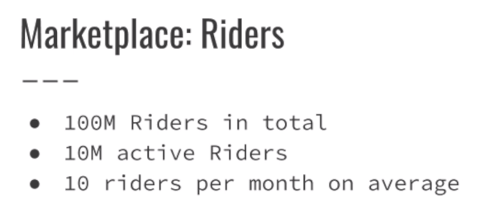

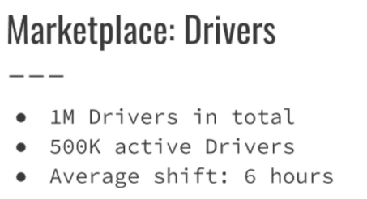

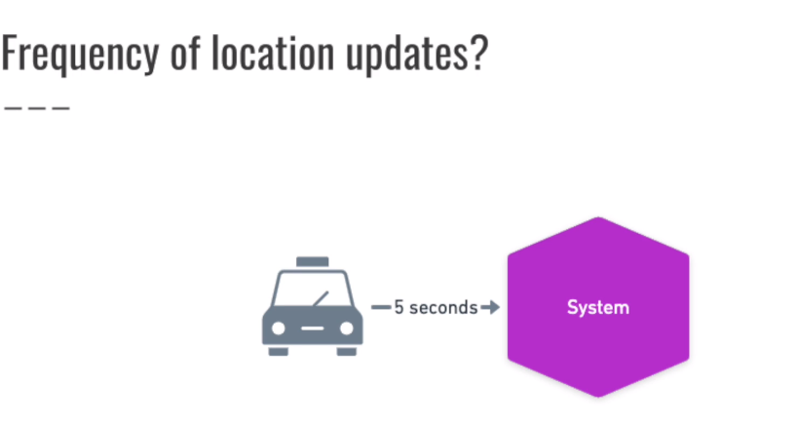

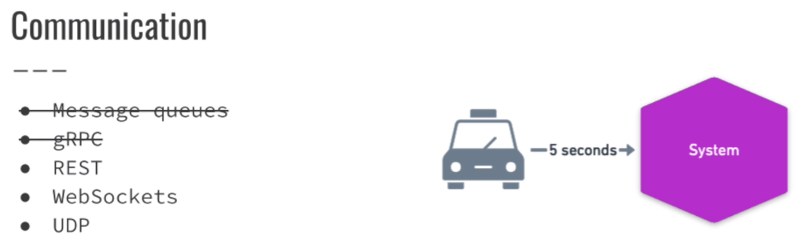

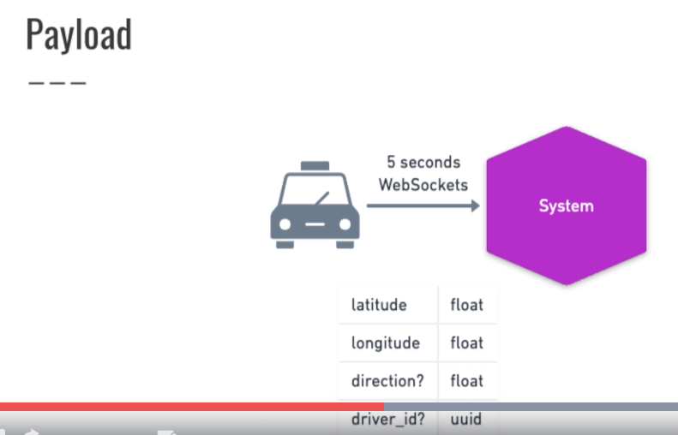

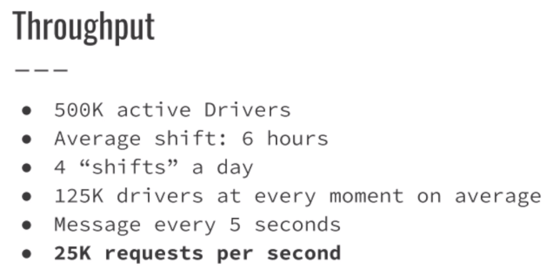

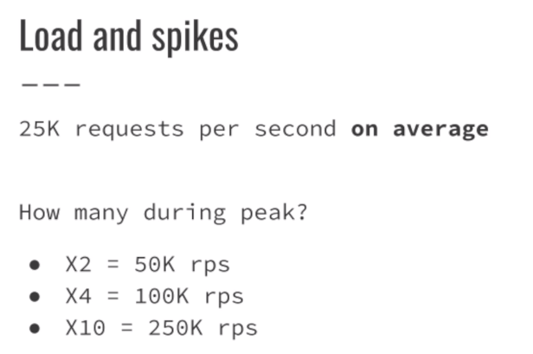



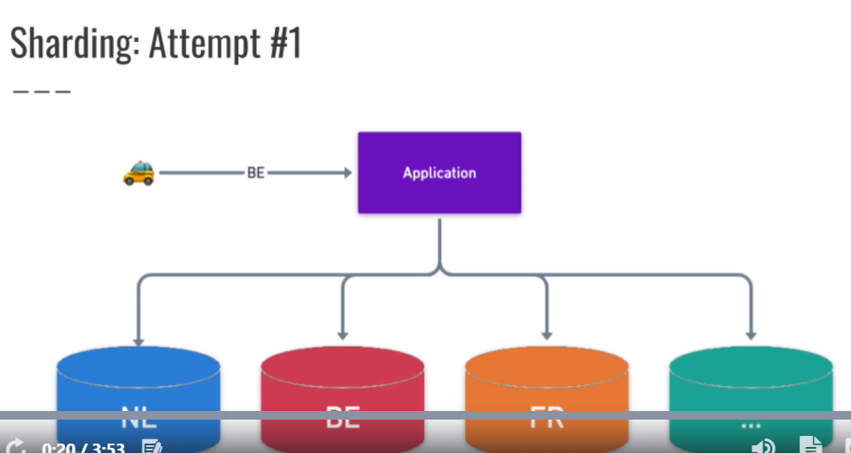

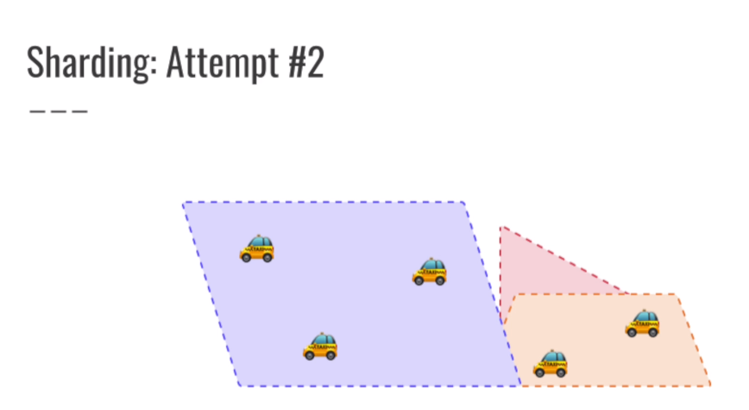

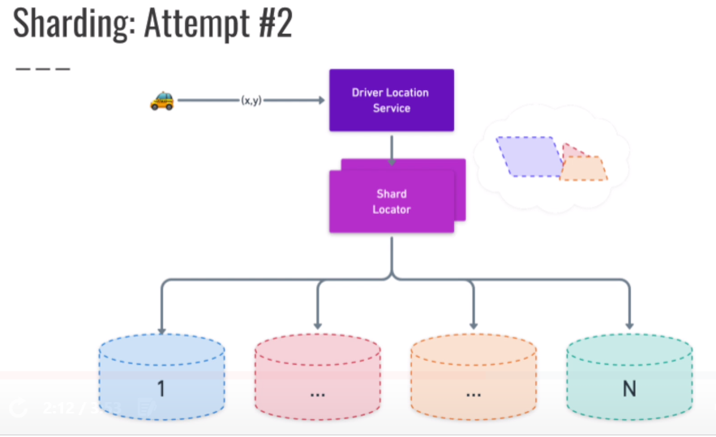



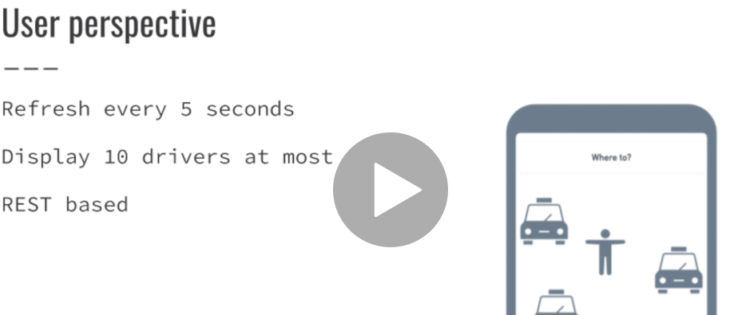

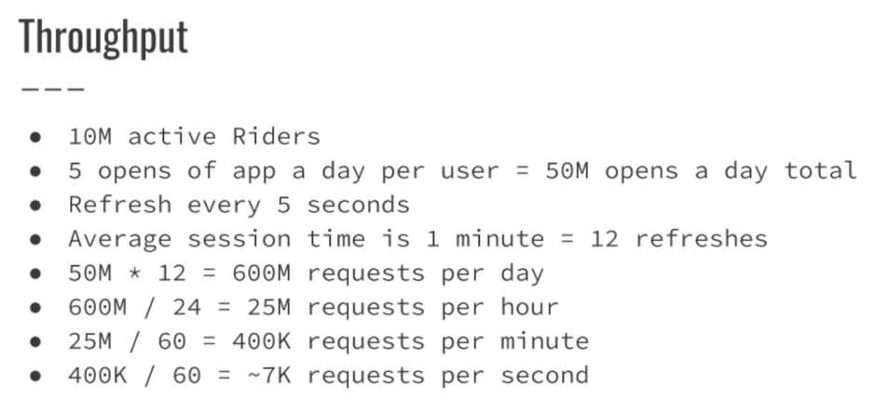

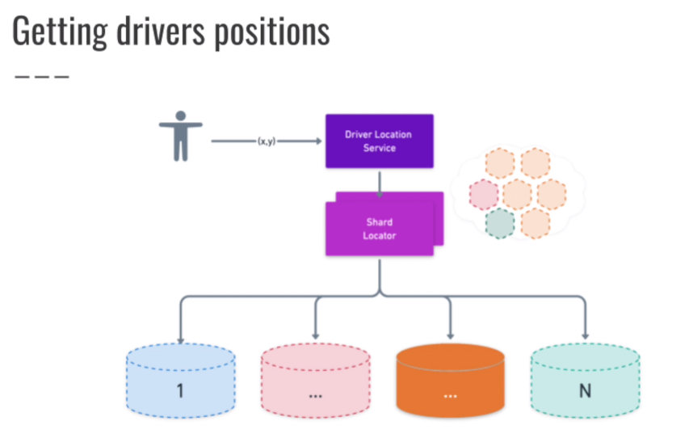

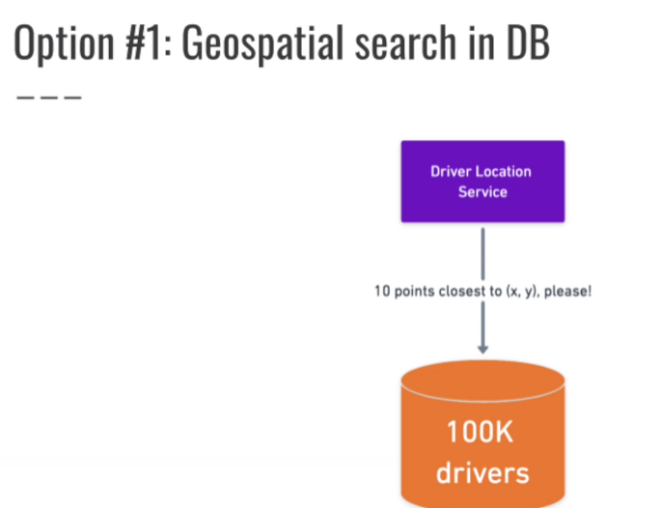

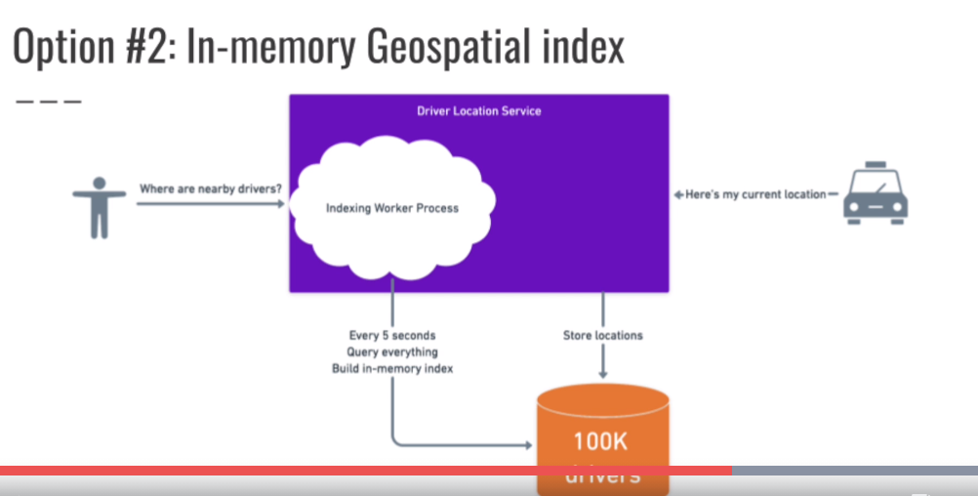



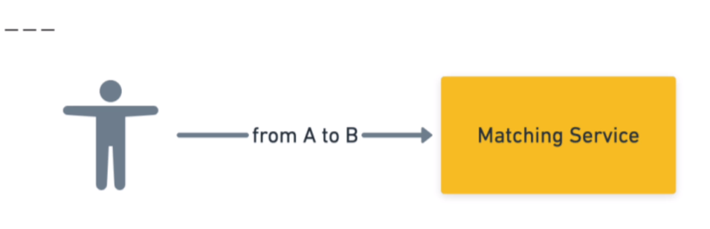

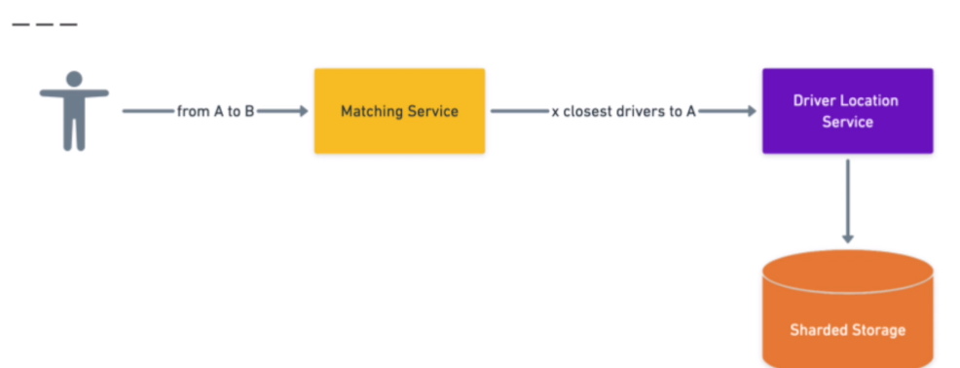

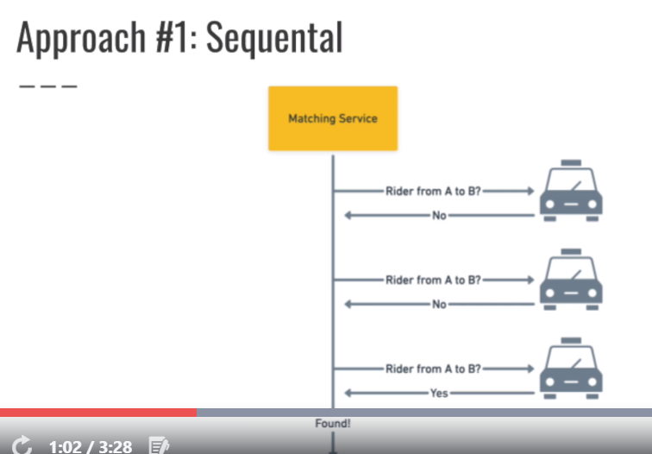

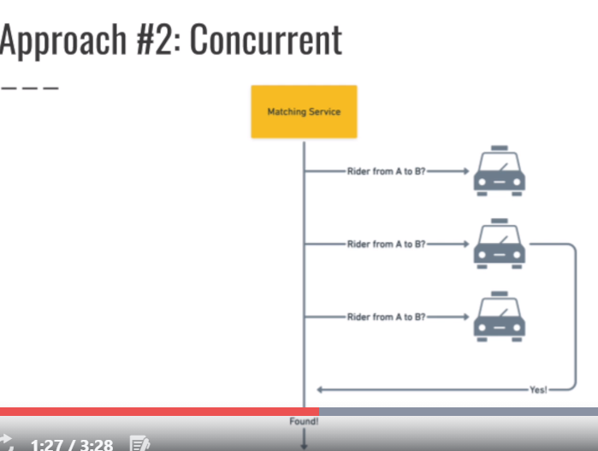

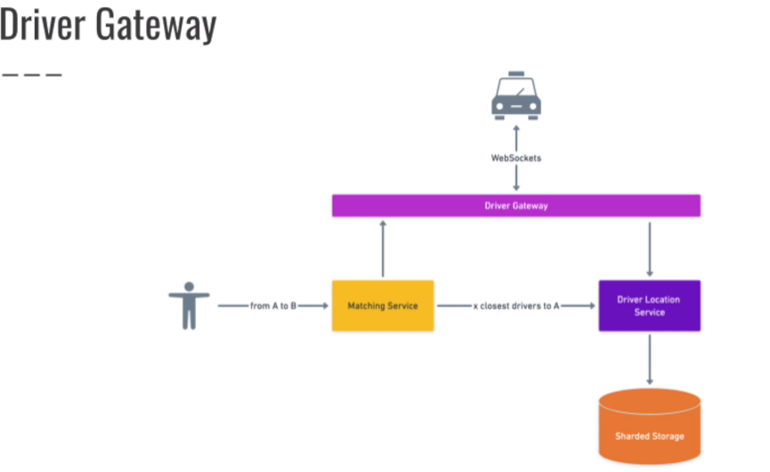

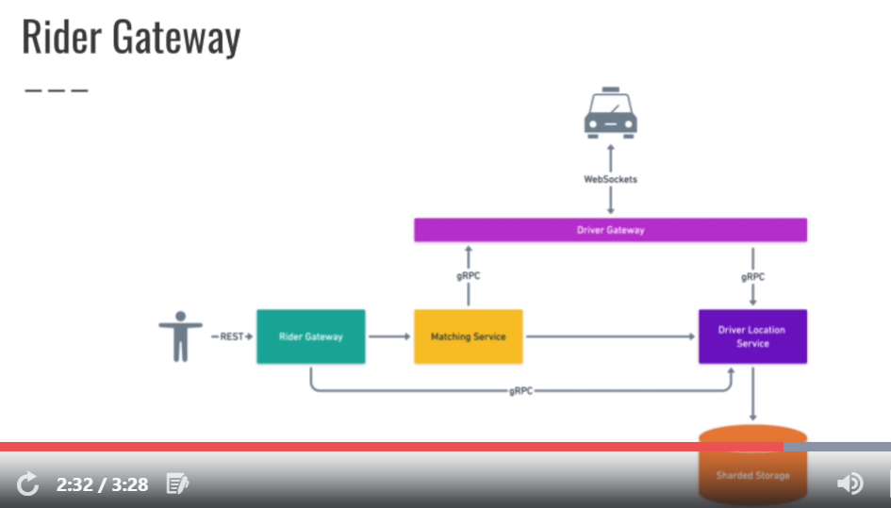

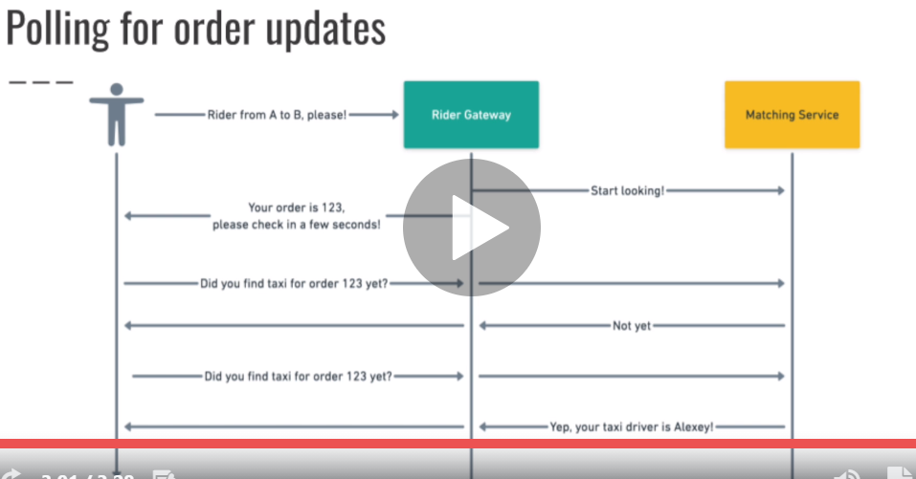



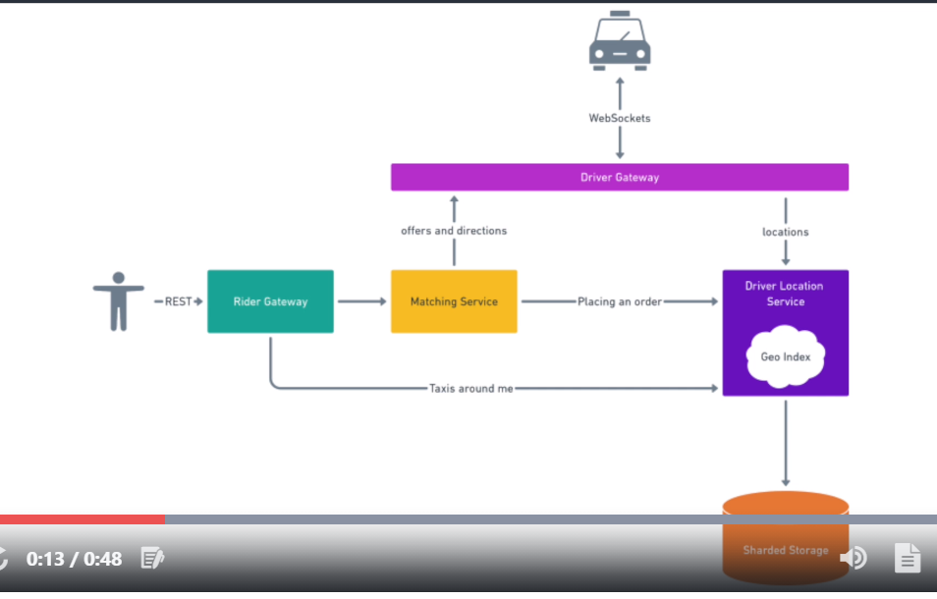



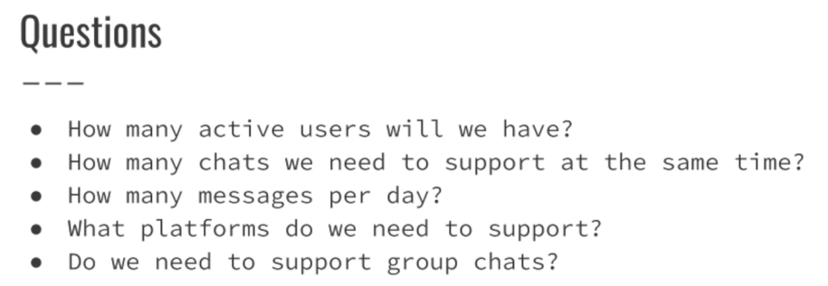

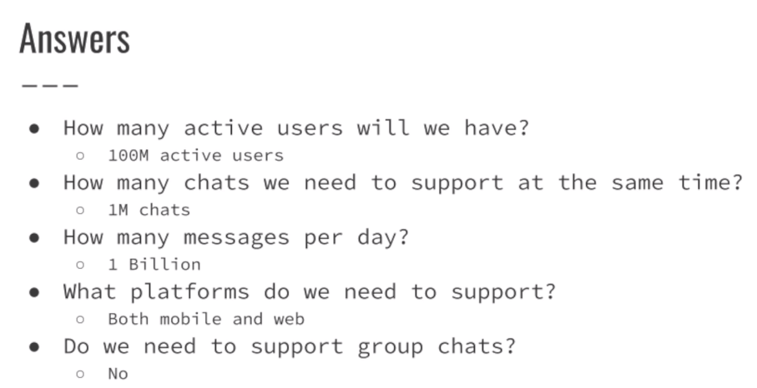

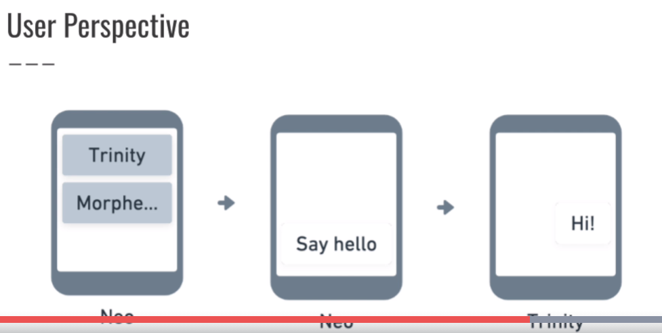



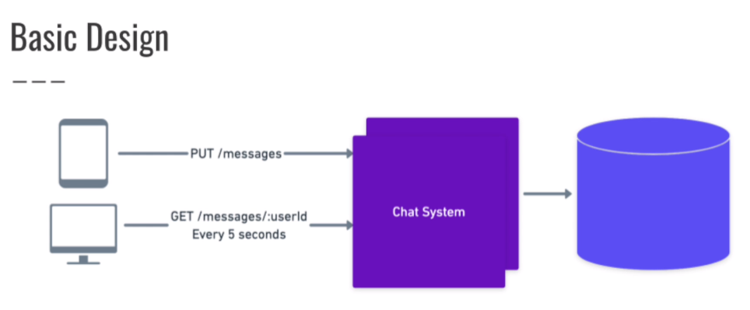

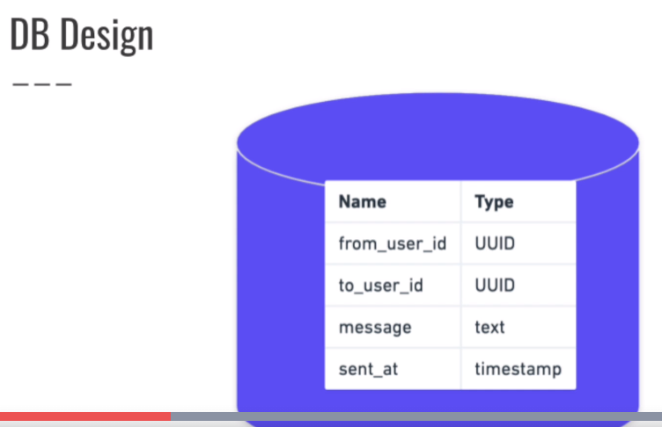

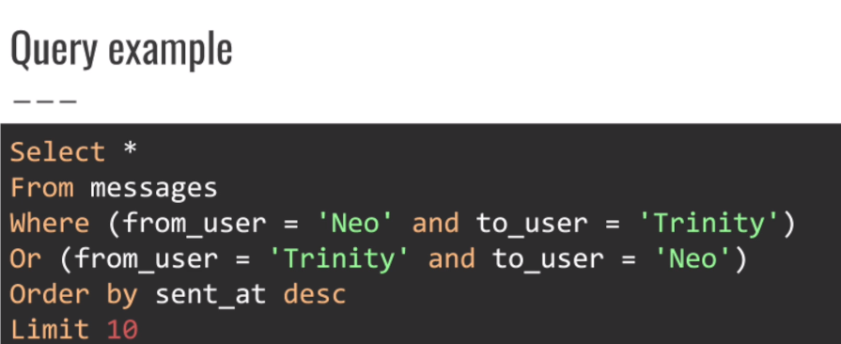

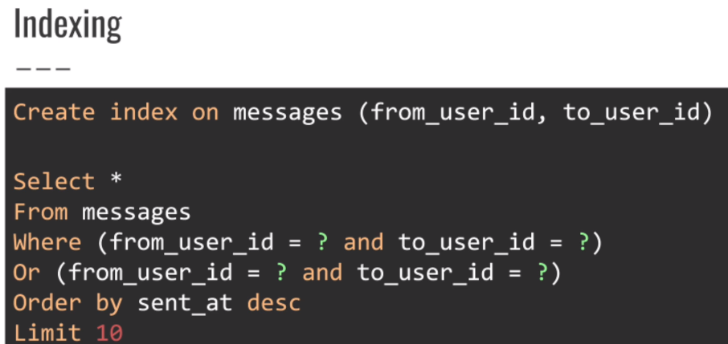

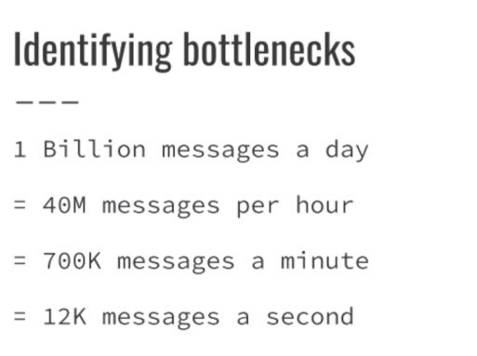

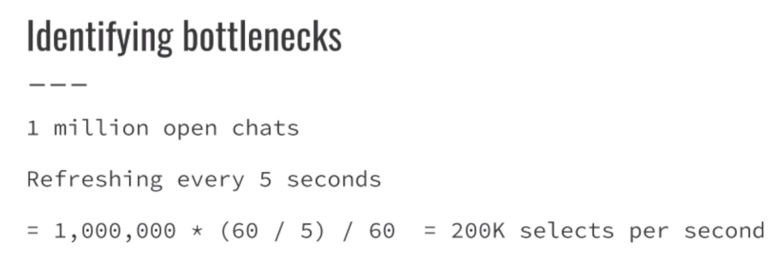



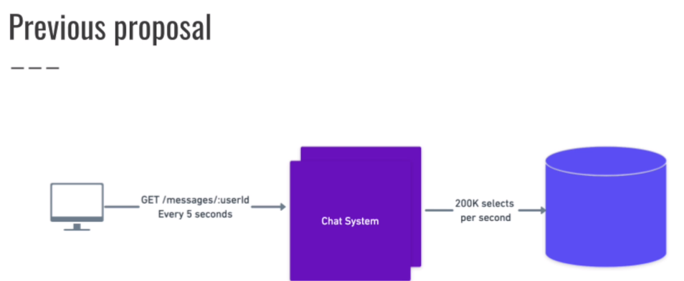

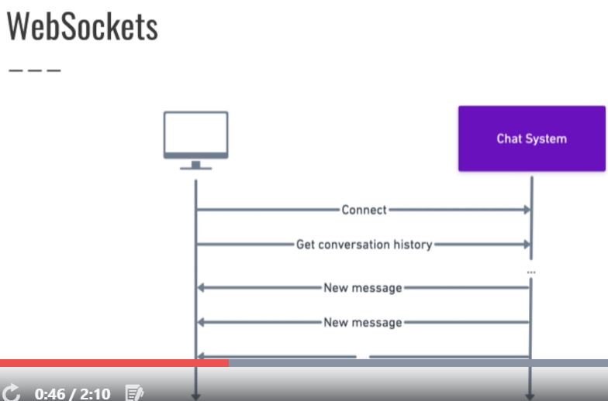

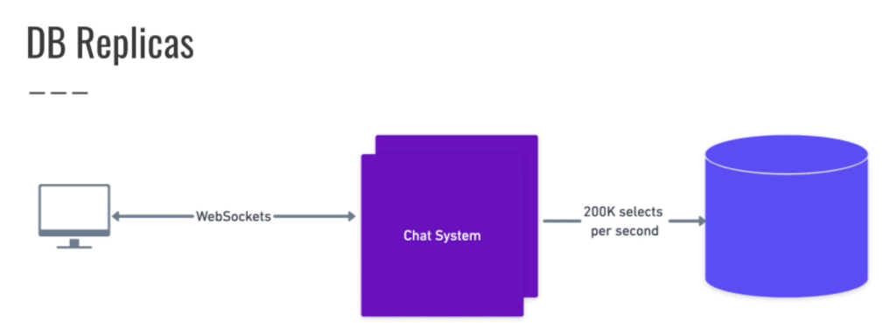

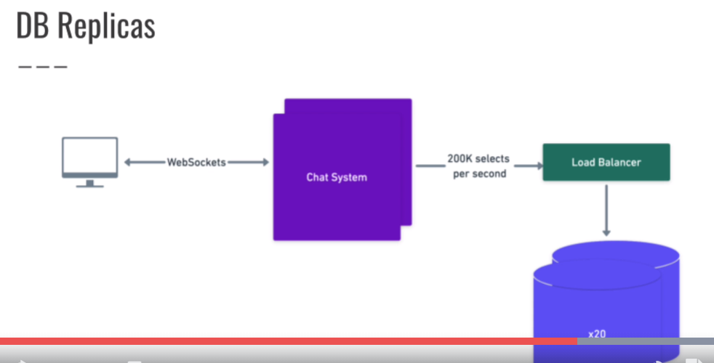



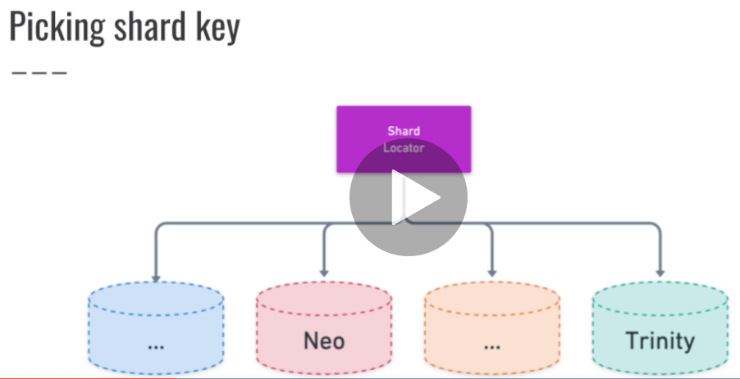

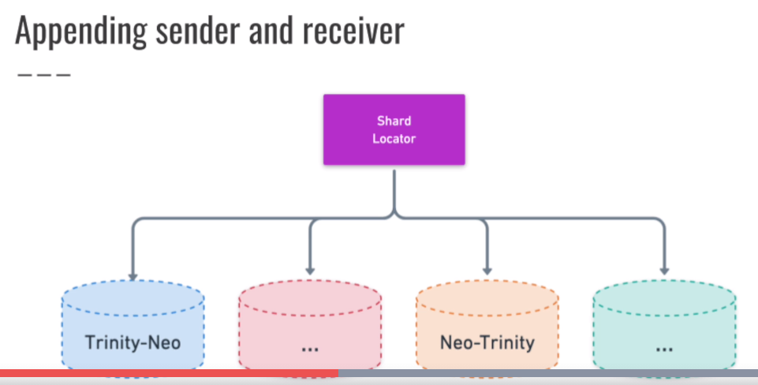

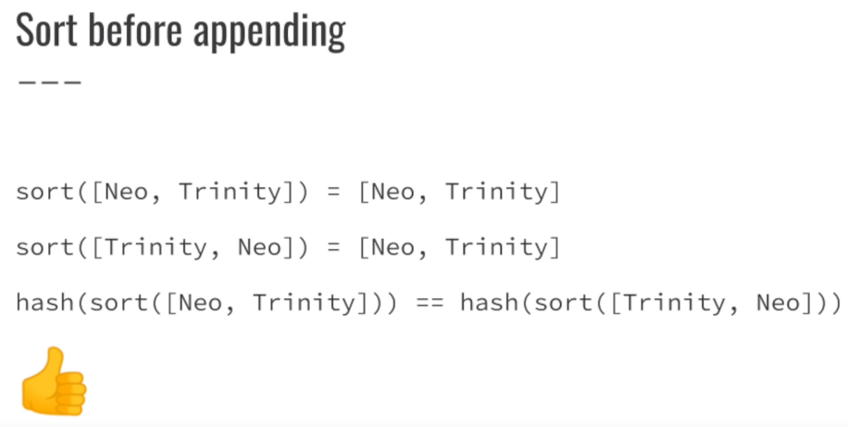

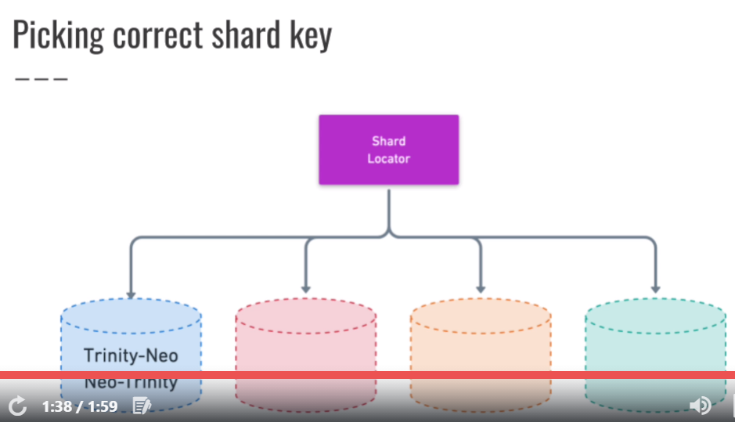

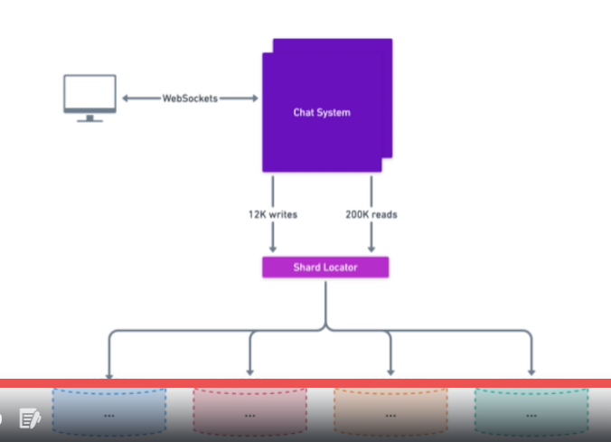

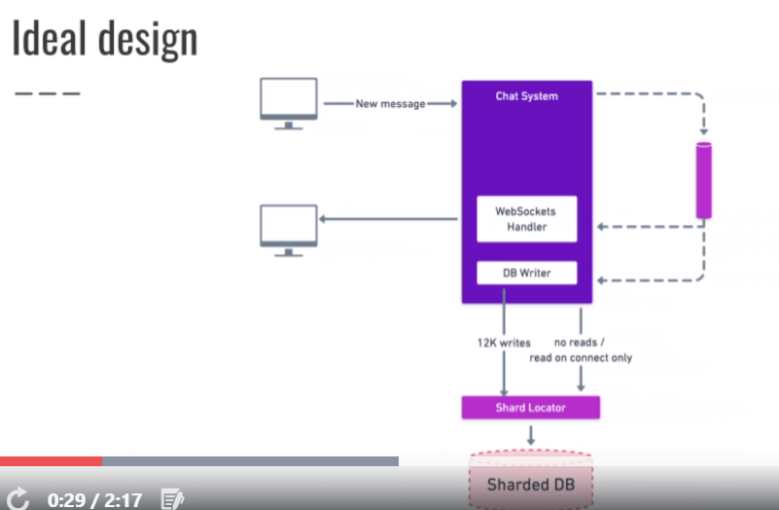

Dotted line for asynchronous transactions.

